Project Outline & Planning

Intelligent Receipt Information Extraction (IRIE)
A Unified Vision-Language Approach for Transforming Unstructured Receipt Images into Structured Data

System architecture
The system is based on the LayoutLMv3 architecture[1], which is a unified multimodal Transformer. Unlike previous versions that relied on complex CNN backbones for visual features, LayoutLMv3 simplifies the pipeline by treating both text and images as sequences of tokens.

- Multimodal Transformer Encoder: A single Transformer backbone that processes both text embeddings and image patches simultaneously.
- Linear Patch Embedding: The input document image is divided into patches (shown in orange color), which are flattened and projected into a visual embedding space.
- Text Embedding: Is a combination of word embeddings and position embeddings (shown in blue color). The position embeddings include 1D position and 2D layout position embeddings, where the 1D position refers to the index of tokens within the text sequence, and the 2D layout position refers to the bounding box coordinates of the text sequence.
- Unified Representation: By concatenating text and visual embeddings into one sequence, the model learns cross-modal interactions (e.g., how the visual style of a "Total" amount relates to the text "Total").
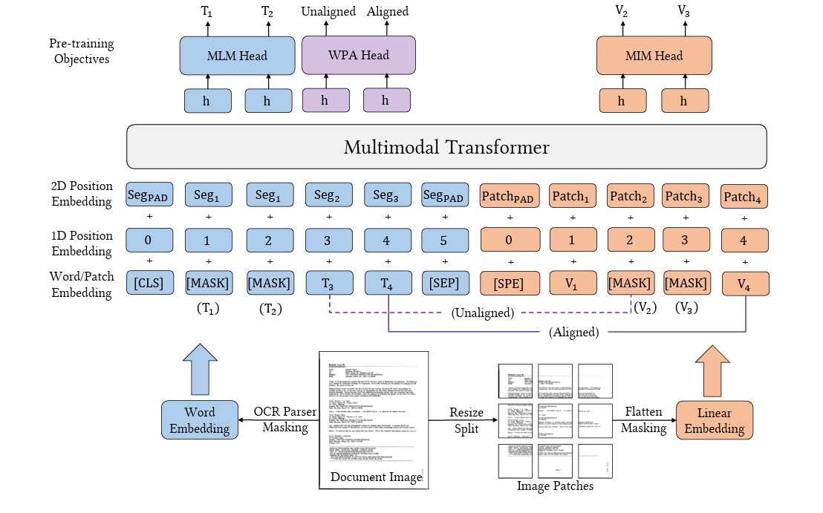

Algorithms / models to be used
The core model is LayoutLMv3, which uses three primary self-supervised pre-training objectives to understand document layouts:
- Masked Language Modeling (MLM): The model predicts masked text tokens based on the surrounding text and visual context.
- Masked Image Modeling (MIM): The model predicts masked image patches, helping it learn the visual structure of documents (lines, tables, logos).
- Word-Patch Alignment (WPA): A unique cross-modal algorithm that predicts whether a specific image patch corresponds to a specific text word, forcing the model to align text with its precise location in the image.

Dataset description
The SROIE (Scanned Receipts OCR and Information Extraction)[2] dataset is a standard benchmark for document intelligence.
- Source: Originally released for the ICDAR 2019 Robust Reading Challenge.
- Size: Contains 973 scanned receipts in total.
  - Training Set: ~626 receipts.
  - Test Set: ~347 receipts.
- Type: Multi-modal dataset consisting of:
  - Images: Scanned receipt images in .jpg format.
  - OCR Text: Individual .txt files containing the text recognized from the scans along with their 2D coordinates (bounding boxes).
  - Key Entities (Labels): Ground truth .txt and .json files containing four target fields: Company, Address, Date, and Total.
- Language: English.

Milestones and timeline

- 1 March 2026: Implementation
- 5 April 2026: Optimization & Enhancement
- 24 May 2026: Deployment

Evaluation metrics

Precision
Precision measures the "quality" of the model's predictions. Out of all the entities the model claimed were correct (e.g., all things it labeled as "Total"), how many were actually correct?
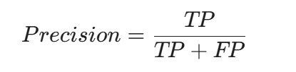
TP (True Positive): Correctly identified entity (e.g., correctly labeled the "Total" amount).
FP (False Positive): Incorrectly identified entity (e.g., labeled the "Address" as the "Total").

Recall
Recall measures the "quantity" or completeness. Out of all the actual entities present in the receipt, how many did the model successfully find?
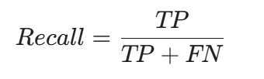
FN (False Negative): An entity that existed but the model missed or labeled as "O" (Outside).

F1-Score
The F1-score is the harmonic mean of Precision and Recall. It is the primary metric for SROIE because it penalizes models that try to "cheat" by only predicting easy entities (high precision) or by guessing everything (high recall).
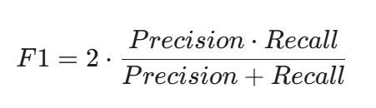

Accuracy
While less emphasized in NER tasks, accuracy measures the total percentage of correct individual token predictions.
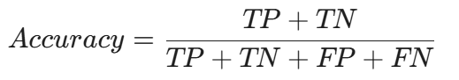

Risk assessment and fallback plans

High Error in Zero-Shot Examples
  - The Risk: LayoutLMv3 may struggle with "zero-shot" scenarios—receipts or documents with layouts entirely different from the training data (e.g., a handwritten invoice or a non-standard digital receipt). This leads to a sharp drop in Precision and Recall.

  - Fallback Plan: Implement Data Augmentation and Out-of-Distribution (OOD) Detection. When the model encounters a low-confidence sample, the system should flag it for manual review or utilize a specialized "fallback" model trained on a wider variety of document types to broaden the model's scope.

Confusion with Unclear or Noisy Text
  - The Risk: Scanned receipts often suffer from motion blur, low lighting, or thermal fading. Since LayoutLMv3 relies on OCR-generated bounding boxes, poor text quality causes "garbage in, garbage out" errors.

  - Fallback Plan: Integrate advanced Image Pre-processing methods. Before the document reaches the model, apply Binarization (to sharpen text), Denoising, and Deskewing. If OCR confidence remains low, the system can trigger a secondary, high-accuracy OCR engine (like Tesseract or Google Vision) to re-process the problematic patches.

Catastrophic Forgetting
  - The Risk: When fine-tuning the pre-trained LayoutLMv3 on a specific dataset like SROIE, the model may "forget" the general document-understanding knowledge it gained during pre-training, making it brittle and over-fitted to a single format.

  - Fallback Plan: Employ Parameter-Efficient Fine-Tuning (PEFT) techniques such as LoRA (Low-Rank Adaptation). Instead of updating all billions of parameters, you only train a small subset. Alternatively, use Model Pruning to remove redundant neurons, which helps the model retain its core structural knowledge while learning the specific patterns of your dataset.

